Table of Contents
Bagging 1
Bagged Classifier 1
Bagged Regressors 4
Grid Searching 5
Boosting 8
Adaptive Boosting 8
Gradient Boosting 12
Xtreme Gradient Boosting 12
Ensembles 14
Stacked Models 15
Stacking Regression 15
Stacking Classification 18

Bagging
Bagging involves averaging the predictions from the weak learners to generate a more stable result with less variance. ‘Bagging’ is a term that is derived from the terms “bootstrapping” and “aggregating”. Bootstrapping involves sampling with replacement. Weak learners of the same type are built with the bootstrapped data.

A random forest is a great example of a bagging algorithm since it combines many weak decision trees with random data. Other types of learners can be bagged as well.

Bagged Classifier
We have looked at bagging with random forests. We can perform bagging with other model types as well.

Example 1: Bagging
Next in this example, several stand-alone and bagged classifiers are compared. These classifiers include:
- KNeighborsClassifier()
- SVC()
- RidgeClassifier()

Bagging often offers a slight improvement in accuracy with generally less variance in most cases. Overall the KNeighborsClassifier appears to gain the most from bagging. (see Table 1). However, when bagging or not, RidgeClassifier scores already are superior to KNeighborsClassifier.

Table 1: Comparing Stand-Alone and Bagged Classifiers
*** KNeighborsClassifier ***
precision recall f1-score support
0 0.55 0.72 0.62 53
1 0.35 0.23 0.28 53
2 0.64 0.67 0.66 58

*** Bagged: KNeighborsClassifier ***
precision recall f1-score support
0 0.64 0.79 0.71 53
1 0.58 0.26 0.36 53
2 0.66 0.84 0.74 58

*** SVC ***
precision recall f1-score support
0 0.57 0.81 0.67 53
1 0.54 0.13 0.21 53
2 0.63 0.81 0.71 58
*** Bagged: SVC ***
precision recall f1-score support
0 0.60 0.83 0.70 53
1 0.53 0.17 0.26 53
2 0.62 0.79 0.70 58

*** RidgeClassifier ***
precision recall f1-score support
0 0.62 0.83 0.71 53
1 0.50 0.25 0.33 53
2 0.75 0.86 0.80 58

*** Bagged: RidgeClassifier ***
precision recall f1-score support
0 0.58 0.83 0.68 53
1 0.47 0.13 0.21 53
2 0.70 0.88 0.78 58

Here is the code for this sample:
import pandas as pd

# Get the housing data
df = pd.read_csv('housing_classification.csv')
# Show all columns.
pd.set_option('display.max_columns', None)
pd.set_option('display.width', 1000)
print(df.head(5))

# Split into two sets
y = df['price']
X = df.drop('price', axis=1)

from sklearn.ensemble import BaggingClassifier
from sklearn.neighbors import KNeighborsClassifier
from sklearn.linear_model import RidgeClassifier
from sklearn.svm import SVC
from sklearn.metrics import classification_report

# Create classifiers
knn = KNeighborsClassifier()
svc = SVC()
rg = RidgeClassifier()

# Build array of classifiers.
classifierArray = [knn, svc, rg]

def showStats(classifier, scores):
print(classifier + ": ", end="")
strMean = str(round(scores.mean(),2))

strStd = str(round(scores.std(),2))
print("Mean: " + strMean + " ", end="")
print("Std: " + strStd)

from sklearn.model_selection import train_test_split
X_train, X_test, y_train, y_test = train_test_split(X, y, test_size=0.30)

def evaluateModel(model, X_test, y_test, title):
print("\n*** " + title + " ***")
predictions = model.predict(X_test)
report = classification_report(y_test, predictions)
print(report)

# Search for the best classifier.
for clf in classifierArray:
modelType = clf.__class__.__name__

# Create and evaluate stand-alone model.
clfModel = clf.fit(X_train, y_train)
evaluateModel(clfModel, X_test, y_test, modelType)

# max_features means the maximum number of features to draw from X.
# max_samples sets the percentage of available data used for fitting.
bagging_clf = BaggingClassifier(clf, max_samples=0.4, max_features=6,
n_estimators=100)
baggedModel = bagging_clf.fit(X_train, y_train)
evaluateModel(baggedModel, X_test, y_test, "Bagged: " + modelType)

Exercise 1 (2 marks)
Compared to when max_features is 11, what happens if you set max_features to 3. Do the results for KNeighborsClassifier improve? Please explain.
This is before with max_features = 6 by the given code
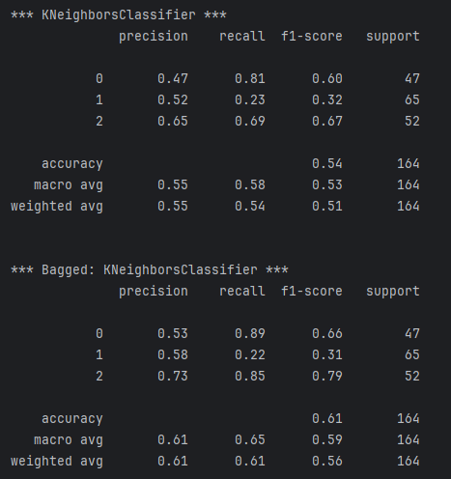
This is after with max_features = 3
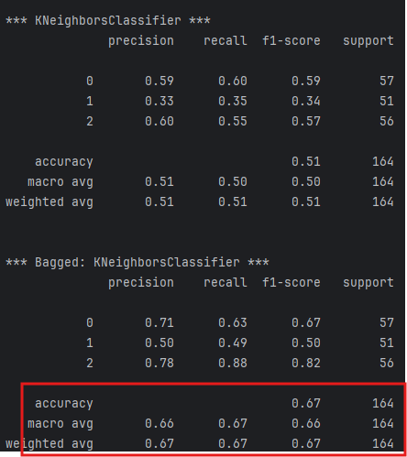
In terms of Bagging Yes they improved as Bagging uses the weakests learners and creates stable and less variant results

Exercise 2 (3 marks)
Modify Example 1 by importing the LogisticRegression class.
from sklearn.linear_model import LogisticRegression

Define the logistic regression classifier as shown here:
lr = LogisticRegression(fit_intercept=True, solver='liblinear')

Modify the classifier array to also include your logistic regressor in the grid search. Show the output here:
This is added on to the output
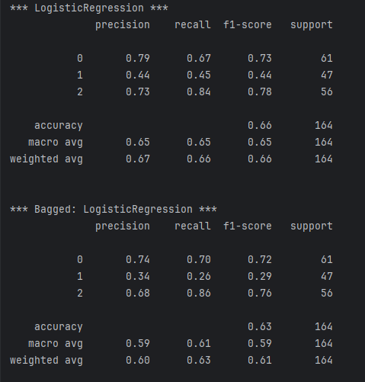

How does the logistic regressor compare to the best performing classifier?
The best performing in this case is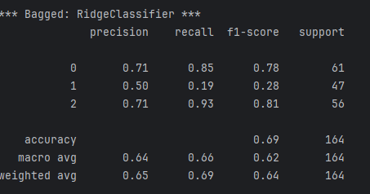
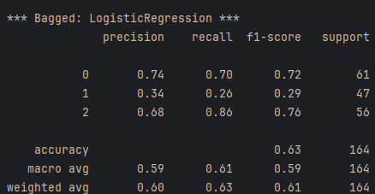
It is not as good in comparison to the best performing model

Bagged Regressors
In addition to classification problems, you can use bagging to create an ensemble of regressors.

Example 2: Bagging with Linear Regression
This example uses a bagged regressor for linear regression to predict the total petrol consumption. The results show that the learning ensemble does more poorly but we will try to fix this in the next example

****** Ensemble
Root Mean Squared Error: 65.7520989586188

****** Linear Regression
Root Mean Squared Error: 70.4921615920565

For now, here is how to implement a basic ensemble for linear regression:
import pandas as pd
from sklearn.ensemble import BaggingRegressor
from sklearn.linear_model import LinearRegression

from sklearn.model_selection import train_test_split
import numpy as np
from sklearn.metrics import mean_squared_error

# Show all columns.
pd.set_option('display.max_columns', None)
pd.set_option('display.width', 1000)

# Load and prepare data.
FOLDER = '/users/pm/desktop/daydocs/data/'
FILE = 'petrol_consumption.csv'
dataset = pd.read_csv(FOLDER + FILE)
print(dataset)
X = dataset.copy()
del X['Petrol_Consumption']
y = dataset[['Petrol_Consumption']]

# Create random split.
X_train, X_test, y_train, y_test = train_test_split(X, y, test_size=0.2)

def evaluateModel(model, X_test, y_test, title):
print("\n****** " + title)
predictions = model.predict(X_test)
print('Root Mean Squared Error:',
np.sqrt(mean_squared_error(y_test, predictions)))

# Build linear regression ensemble.
ensembleModel = BaggingRegressor(base_estimator=LinearRegression(),max_features=4,
max_samples =0.5,
n_estimators=10).fit(X_train, y_train)
evaluateModel(ensembleModel, X_test, y_test, "Ensemble")

# Build stand alone linear regression model.
model = LinearRegression()
model.fit(X_train, y_train)
evaluateModel(model, X_test, y_test, "Linear Regression")

Grid Searching
With countless parameter combinations for ensembles and potential models it helps to be able to grid search different combinations to find the optimal combination.

Example 3: Grid Searching Bagging Regressor Parameters
This example actually shows that it is possible to reduce the variance with an ensemble. The optimal parameter combination is found through a grid search.

Since the data split and sampling is random, the results will vary each run. However, it appears that an ensemble with a maximum of 4 features and 800 estimators can out-perform linear regression.
estimators features rmse type
6 800 4 30.910344 Ensemble
4 800 3 47.448549 Ensemble
10 900 4 52.893641 Ensemble
2 750 4 53.472123 Ensemble
8 900 3 70.127002 Ensemble
14 1000 4 73.186699 Ensemble
12 1000 3 110.820228 Ensemble
0 750 3 122.607095 Ensemble
7 None None 33.178561 Linear Regression
5 None None 45.119426 Linear Regression
3 None None 51.786050 Linear Regression
11 None None 52.931385 Linear Regression
9 None None 60.539137 Linear Regression
15 None None 72.666123 Linear Regression
13 None None 97.148495 Linear Regression
1 None None 116.922646 Linear Regression

The code that performs the grid search is similar to the code in Example 2. This code however loops through different combinations of numbers of estimators and maximum features.

import pandas as pd
from sklearn.ensemble import BaggingRegressor
from sklearn.linear_model import LinearRegression

from sklearn.model_selection import train_test_split
import numpy as np
from sklearn.metrics import mean_squared_error

# Show all columns.
pd.set_option('display.max_columns', None)
pd.set_option('display.width', 1000)

# Load and prepare data.
FOLDER = '/users/pm/desktop/daydocs/data/'
FILE = 'petrol_consumption.csv'
dataset = pd.read_csv(FOLDER + FILE)
print(dataset)
X = dataset.copy()
del X['Petrol_Consumption']
y = dataset[['Petrol_Consumption']]

feature_combo_list = []
def evaluateModel(model, X_test, y_test, title, num_estimators, max_features):
print("\n****** " + title)
predictions = model.predict(X_test)
rmse = np.sqrt(mean_squared_error(y_test, predictions))

# Store statistics and add to list.
stats = {"type":title, "rmse":rmse,
"estimators":num_estimators, "features":max_features}
feature_combo_list.append(stats)

num_estimator_list = [750, 800, 900, 1000]
max_features_list = [3, 4]

for num_estimators in num_estimator_list:
for max_features in max_features_list:
# Create random split.
X_train, X_test, y_train, y_test = train_test_split(X, y, test_size=0.2)

import numpy as np

# Build linear regression ensemble.
ensembleModel = BaggingRegressor(estimator=LinearRegression(),
max_features=max_features,
# Can be percent (float) or actual
# total of samples (int).
max_samples =0.5,
n_estimators=num_estimators).fit(X_train, y_train.values.ravel())
evaluateModel(ensembleModel, X_test, y_test, "Ensemble",
num_estimators, max_features)

# Build stand alone linear regression model.
model = LinearRegression()
model.fit(X_train, y_train)
evaluateModel(model, X_test, y_test, "Linear Regression", None, None)

# Build data frame with dictionary objects.
dfStats = pd.DataFrame()
print(dfStats)
for combo in feature_combo_list:
dfStats = pd.concat([dfStats,
pd.DataFrame.from_records([combo])],
ignore_index=True)

# Sort and show all combinations.
# Show all rows
pd.set_option('display.max_rows', None)
dfStats = dfStats.sort_values(by=['type', 'rmse'])
print(dfStats)

Exercise 3 (6 marks)
Modify the code in Example 3 so you can include the maximum samples in the grid search in addition to searching on the optimal number of features. Also, expand the range of maximum features to [0.2, 0.4, 0.6]. Show your revised program here:
def ex3_grid_searching():
import pandas as pd
from sklearn.ensemble import BaggingRegressor
from sklearn.linear_model import LinearRegression
from sklearn.model_selection import train_test_split
import numpy as np
from sklearn.metrics import mean_squared_error
# Show all columns.
pd.set_option('display.max_columns', None)
pd.set_option('display.width', 1000)
# Load and prepare data.
FOLDER = '../Datasets/'
FILE = 'petrol_consumption.csv'
dataset = pd.read_csv(FOLDER + FILE)
print(dataset)
X = dataset.copy()
del X['Petrol_Consumption']
y = dataset[['Petrol_Consumption']]
feature_combo_list = []
def evaluateModel(model, X_test, y_test, title, num_estimators, max_features):
print("\n****** " + title)
predictions = model.predict(X_test)
rmse = np.sqrt(mean_squared_error(y_test, predictions))
# Store statistics and add to list.
stats = {"type": title, "rmse": rmse,
"estimators": num_estimators, "features": max_features}
feature_combo_list.append(stats)
num_estimator_list = [750, 800, 900, 1000]
max_features_list = [0.2, 0.4, 0.6, 3, 4]
for num_estimators in num_estimator_list:
for max_features in max_features_list:
# Create random split.
X_train, X_test, y_train, y_test = train_test_split(X, y, test_size=0.2)
import numpy as np
# Build linear regression ensemble.
ensembleModel = BaggingRegressor(estimator=LinearRegression(),
max_features=max_features,
# Can be percent (float) or actual
# total of samples (int).
max_samples=0.5,
n_estimators=num_estimators).fit(X_train, y_train.values.ravel())
evaluateModel(ensembleModel, X_test, y_test, "Ensemble",
num_estimators, max_features)
# Build stand alone linear regression model.
model = LinearRegression()
model.fit(X_train, y_train)
evaluateModel(model, X_test, y_test, "Linear Regression", None, None)
# Build data frame with dictionary objects.
dfStats = pd.DataFrame()
print(dfStats)
for combo in feature_combo_list:
dfStats = pd.concat([dfStats,
pd.DataFrame.from_records([combo])],
ignore_index=True)
# Sort and show all combinations.
# Show all rows
pd.set_option('display.max_rows', None)
dfStats = dfStats.sort_values(by=['type', 'rmse'])
print(dfStats)
ex3_grid_searching()

Show your modified output here:
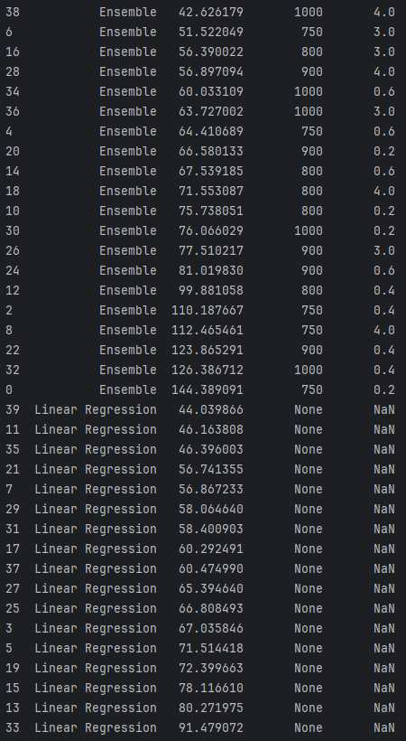

Boosting
Boosting is an ensemble technique which can often improve model performance. With boosting, models are added to an ensemble sequentially instead of all at once.

This article offers a good summary of boosting algorithms.
https://aws.amazon.com/what-is/boosting/

Adaptive Boosting
With adaptive boosting, when a new model is created, samples that are incorrectly predicted are weighted higher in the sample pool. Subsequent models that are built have a better chance to learn from past mistakes. Adaptive boosting is suitable for classification. Josh Stormer provides an excellent overview of how boosting (with AdaBoost) is implemented at:

https://www.youtube.com/watch?v=LsK-xG1cLYA&t=1020s

With AdaBoost, the trees usually only include a root node and two leaves. These short trees are called stumps. Stumps on their own though are not great for classifications. | 

A stump generally uses one variable to make decisions. | 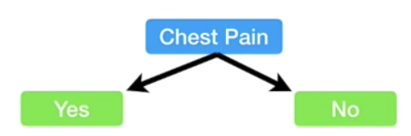

With AdaBoost some stumps are weighted more in the classification. | 

Errors that are made by the first stump influence how the second stump is made and so on…. | 

 | For the heart disease prediction example, when the first stump is created, all samples are given the same weight.  Sample Weight = $\frac{1}{Total number of samples}$ = $\frac{1}{8}$

Patient weight turns out to be the best variable to perform the first prediction for heart disease. Only the prediction at the very right is incorrect. It is no coincidence that Gini index is also the lowest compared to all over predictor variables. This stump becomes the first stump in our forest. | 

The patient who is incorrectly classified by the stump actually has heart disease but the stump shown above says they do not. The total error for the stump is therefore $\frac{1}{8}$. The total error always ranges between 0 for a good stump and 1 for a bad stump. | 

The amount of say that a stump has in the prediction is:
Amount of Say = $\frac{1}{2}∙ln⁡(\frac{1-Total Error}{Total Error})$

When total error is small, the amount of say for the sample is large. When the total error is large the amount of say is small. When the total error is 1/8 the amount of say is 0.97.

Exercise 4 (4 marks)
The patient weight is definitely the correct classifier for the first stump. However, if we had chosen chest pain to be the classifier in the first stump 3 classifications would have been incorrect.
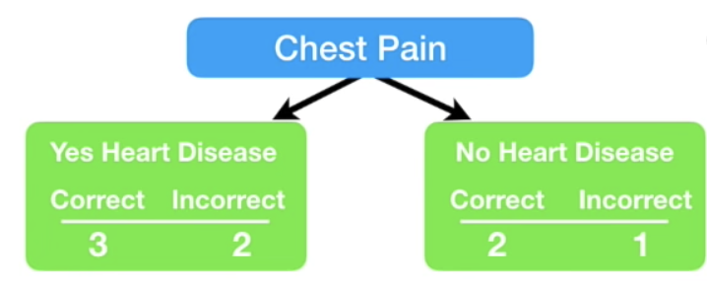
Calculate the amount of say that this stump would have had. Show your calculations here:
Total Error = 3/8 = 0.375
$\frac{1}{2}$ * ln($\frac{1-Total Error}{Total Error}$) $\frac{1}{2}*\ln{(\frac{1-0.375}{0.375})}$ $\frac{1}{2}*ln⁡(\frac{0.625}{0.375})$ $\frac{1}{2}*\ln\left(1.6\right)$ $0.2350$

Continuing on with our example, since the first stump incorrectly classified the heart disease status for the person on the right, we need to adjust the sample weight. | 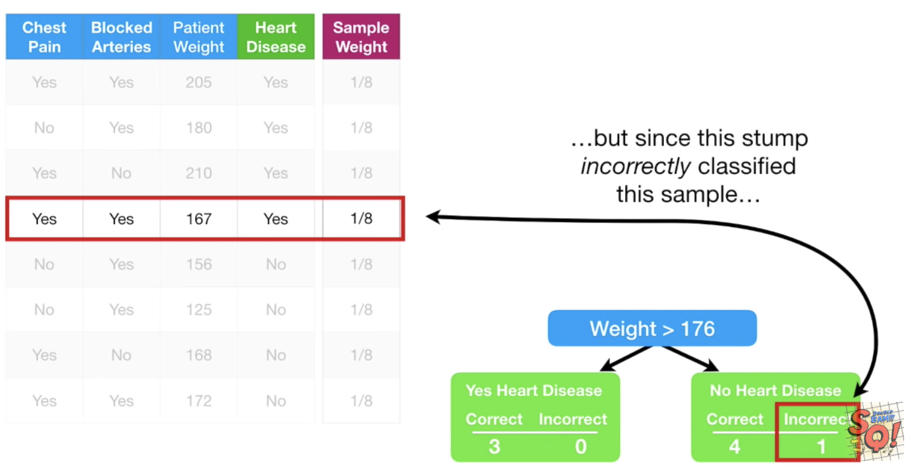
The incorrectly classified sample weight becomes:
New sample weight = sample weight $∙$ $e^{amount of say}$ = $\frac{1}{8}∙e^{0.97}$ = 0.33

The correctly classified sample weights on the other hand must be decreased.
New sample weight = sample weight $∙$ $e^{-amount of say}$ = $\frac{1}{8}∙e^{-0.97}$ = 0.05

These are the weights after at the very right. | 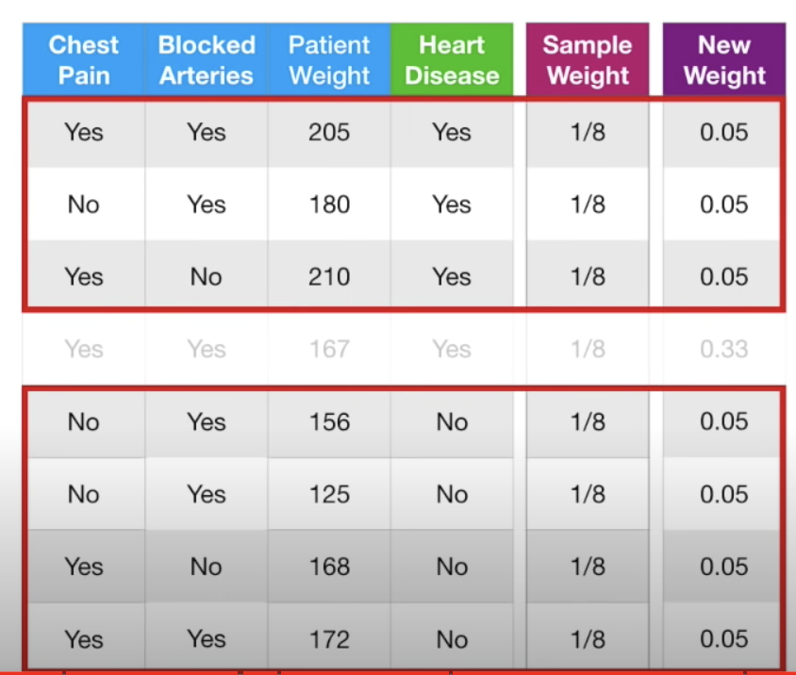

Next, we need to normalize the weights so they sum up to 1.

$\frac{Sample Weight}{Sum of all sample weights}$ = $\frac{0.05}{0.05+0.05+0.05+0.33+0.05+0.05+0.05+0.05}$ = 0.0736

$\frac{Sample Weight}{Sum of all sample weights}$= $\frac{0.33}{0.05+0.05+0.05+0.33+0.05+0.05+0.05+0.05}$ = 0.4853

Next, we throw out the old weights and use the new weights to build our new sample set. To generate the new sample, we take random picks between 0 and 1. If the pick falls between 0 and 0.07 we choose sample 1. If we pick 0.1 we choose sample 2. If we pick between 0.22 and 0.71 we choose sample 4 and so on. | 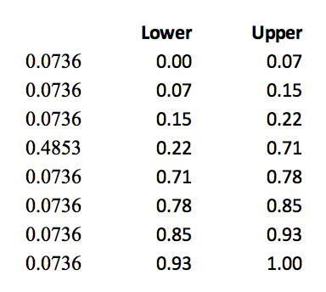

Note that we are likely to choose sample 4 several times as outlined at the right but this is okay since selection is with replacement. | 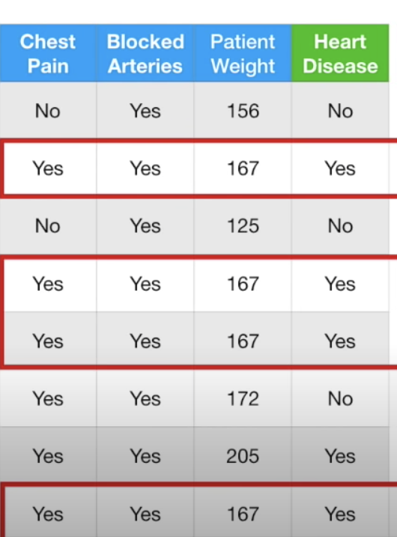
We continue these steps to build more stumps. To make a prediction we sum the ‘amounts of say’ for each stump. The largest sum represents the prediction.

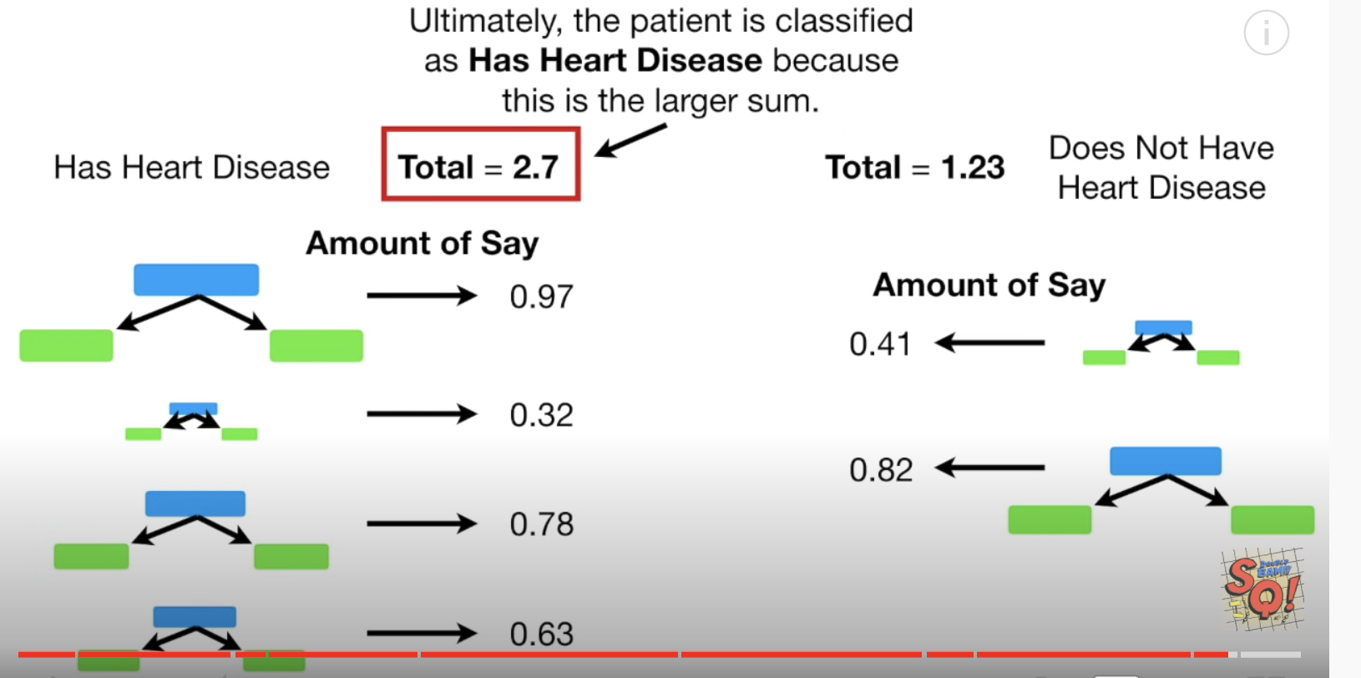

Gradient Boosting
Gradient Boosting (GB) is similar to AdaBoost in that it, too, is a sequential training technique. The difference between AdaBoost and GB is that GB does not give incorrectly classified items more weight. Instead, GB software optimizes the loss function by generating base learners sequentially so that the present base learner is always more effective than the previous one. This method attempts to generate accurate results initially instead of correcting errors throughout the process, like AdaBoost. For this reason, GB software can lead to more accurate results. Gradient Boosting can help with both classification and regression-based problems.

Xtreme Gradient Boosting
Extreme Gradient Boosting (XGBoost) improves gradient boosting for computational speed and scale in several ways. XGBoost uses multiple cores on the CPU so that learning can occur in parallel during training. It is a boosting algorithm that can handle extensive datasets, making it attractive for big data applications. The key features of XGBoost are parallelization, distributed computing, cache optimization, and out-of-core processing.

Example 4: Boosting
This example compares the performance of several boosting classifiers.

ada_boost = AdaBoostClassifier()
grad_boost = GradientBoostingClassifier()
xgb_boost = XGBClassifier()

AdaBoostClassifier
precision recall f1-score support
0 0.68 0.69 0.69 52
1 0.54 0.61 0.57 54
2 0.88 0.76 0.81 58

GradientBoostingClassifier
precision recall f1-score support
0 0.73 0.69 0.71 52
1 0.52 0.59 0.55 54
2 0.79 0.72 0.76 58

XGBClassifier
precision recall f1-score support
0 0.65 0.65 0.65 52
1 0.49 0.56 0.52 54
2 0.84 0.74 0.79 58

Here is the code:
import pandas as pd
from sklearn.metrics import classification_report

# Get the housing data
df = pd.read_csv('housing_classification.csv')
# Show all columns.
pd.set_option('display.max_columns', None)
pd.set_option('display.width', 1000)
print(df.head(5))

# Split into two sets
y = df['price']
X = df.drop('price', axis=1)

from sklearn.model_selection import train_test_split
X_train, X_test, y_train, y_test = train_test_split(X, y, test_size=0.30)

from sklearn.model_selection import cross_val_score
from mlxtend.classifier import EnsembleVoteClassifier
from xgboost import XGBClassifier, plot_importance
from sklearn.ensemble import AdaBoostClassifier, GradientBoostingClassifier

ada_boost = AdaBoostClassifier()
grad_boost = GradientBoostingClassifier()
xgb_boost = XGBClassifier()
classifiers = [ada_boost, grad_boost, xgb_boost]

for clf in classifiers:
print(clf.__class__.__name__)
clf.fit(X_train, y_train)
predictions = clf.predict(X_test)
report = classification_report(y_test, predictions)
print(report)

Exercise 5 (2 marks)
Add a reference for LogisticRegression to Example 4 and include it in the classifier array.
from sklearn.linear_model import LogisticRegression
lr = LogisticRegression(fit_intercept=True, solver='liblinear')

Show the output for Logistic Regression here:
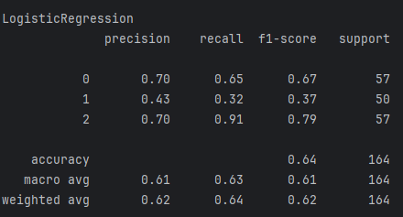

How do the results for LogisticRegression compare with the other classifier algorithms?
The logistic Regression is the lowest performer between these regressors as it has the lowest accuracy, macro and weighted avg.

Exercise 6 (4 marks)
Using code from Example 4, compare the different boosting algorithm performances for the Iris data set. You could use the following code to load and prepare the Iris data.
# Get the housing data
df = pd.read_csv('/Users/pm/Downloads/iris_v2.csv')

dict_map = {'Iris-setosa':0,'Iris-versicolor':1, 'Iris-virginica':2}
df['target'] = df['iris_type'].map(dict_map)

y = df['target']
X = df.copy()
del X['target']
del X['iris_type']

Show your working program here:
df = pd.read_csv('../Datasets/iris_v2.csv')
dict_map = {'Iris-setosa': 0, 'Iris-versicolor': 1, 'Iris-virginica': 2}
df['target'] = df['iris_type'].map(dict_map)
y = df['target']
X = df.copy()
del X['target']
del X['iris_type']
print(X.head())
from sklearn.model_selection import train_test_split
X_train, X_test, y_train, y_test = train_test_split(X, y, test_size=0.30)
from sklearn.model_selection import cross_val_score
from mlxtend.classifier import EnsembleVoteClassifier
from xgboost import XGBClassifier, plot_importance
from sklearn.ensemble import AdaBoostClassifier, GradientBoostingClassifier
from sklearn.linear_model import LogisticRegression
ada_boost = AdaBoostClassifier()
grad_boost = GradientBoostingClassifier()
xgb_boost = XGBClassifier()
lr = LogisticRegression(fit_intercept=True, solver='liblinear')
classifiers = [ada_boost, grad_boost, xgb_boost, lr]
for clf in classifiers:
print(clf.__class__.__name__)
clf.fit(X_train, y_train)
predictions = clf.predict(X_test)
report = classification_report(y_test, predictions)
print(report)

Show the output from your code:
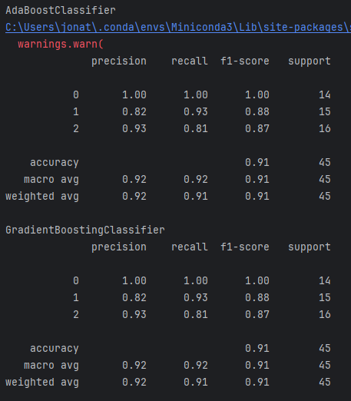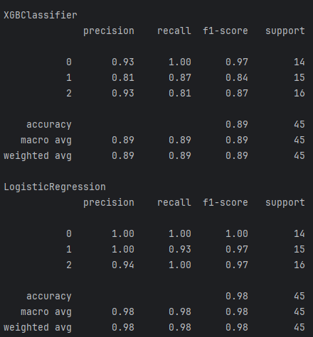

Explain which algorithm performed best and why you made that selection.
Here you can see that logistic regression performs the highest with a 0.98 accuracy. Meaning this is the best performer FOR this dataset.

Ensembles
Ensembles allow you to average the predictions from multiple models to provide a more stable and accurate model.

eclf = EnsembleVoteClassifier(clfs=[ada_boost, grad_boost,
xgb_boost], voting='hard')

- ‘hard’ voting chooses the majority of votes
- ‘soft’ voting averages the percentages of votes for each class.

Ensemble models do not usually end up being the best model but they do weight results from the best models more heavily. As a result ensemble models tend to be very competitive.

Example 5: Ensembles
Starting with Example 4, replace the definition for the classifiers list with the following code which groups the classifiers.

eclf = EnsembleVoteClassifier(clfs=[ada_boost, grad_boost,
xgb_boost], voting='hard')
classifiers = [ada_boost, grad_boost, xgb_boost, eclf]

The output:
AdaBoostClassifier
precision recall f1-score support
0 0.60 0.63 0.61 54
1 0.39 0.47 0.43 51
2 0.80 0.63 0.70 59

GradientBoostingClassifier
precision recall f1-score support
0 0.59 0.65 0.62 54
1 0.45 0.49 0.47 51
2 0.82 0.68 0.74 59

XGBClassifier
precision recall f1-score support
0 0.60 0.61 0.61 54
1 0.46 0.53 0.49 51
2 0.84 0.71 0.77 59

EnsembleVoteClassifier
precision recall f1-score support
0 0.61 0.67 0.64 54
1 0.45 0.49 0.47 51
2 0.82 0.68 0.74 59

Exercise 7 (2 marks)
Describe how the ensemble model in Example 5 performs compared to the individual base models for each of the classes that are being predicted.
Based on the output you can see that it takes the values of each classifier and averages them out
Precison for class zero comes from each of the classifiers result put into an avg
It out performs the adaBoost but it is almost par with the Gboost and xgb
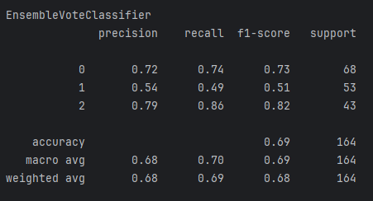

Stacked Models
A stacked model builds a model with the output from multiple models. Stacking can be applied to a combine the outputs from a wide variety of predictive models. Often, stacking helps to improve accuracy.

Stacking Regression

Example 6: Stacking Regression
This example shows how to implement stacking with outputs from the following combination of regressors:

- ElasticNet
- DecisionTreeRegressor
- SVR
- AdaBoostRegressor
- BaggingRegressor
- RandomForestRegressor
- ExtraTreesRegressor

The output when running this program shows that our super learner is competitive when compared to most models.
** Evaluate Base Models **
RMSE:123799.119 ElasticNet
RMSE:352456.005 SVR
RMSE:188327.974 DecisionTreeRegressor
RMSE:155919.974 AdaBoostRegressor
RMSE:136916.041 RandomForestRegressor
RMSE:131182.792 ExtraTreesRegressor

** Evaluate Stacked Model **
RMSE:104680.594 LinearRegression

Here is the code:
from sklearn.linear_model import LinearRegression
from sklearn.linear_model import ElasticNet
from sklearn.tree import DecisionTreeRegressor
from sklearn.svm import SVR
from sklearn.ensemble import AdaBoostRegressor
from sklearn.ensemble import RandomForestRegressor
from sklearn.ensemble import ExtraTreesRegressor
from sklearn.metrics import mean_squared_error
from sklearn.model_selection import train_test_split
import numpy as np
import pandas as pd

# Show all columns.
pd.set_option('display.max_columns', None)
pd.set_option('display.width', 1000)

# Prep data.
PATH = "/users/pm/desktop/daydocs/data/"
CSV_DATA = "USA_Housing.csv"
dataset = pd.read_csv(PATH + CSV_DATA)
print(dataset.head())
X = dataset[['Avg. Area Income','Avg. Area House Age', 'Avg. Area Number of Rooms',\
'Avg. Area Number of Bedrooms', "Area Population"]].values
y = dataset['Price']

def getUnfitModels():
models = list()
models.append(ElasticNet())
models.append(SVR(gamma='scale'))
models.append(DecisionTreeRegressor())
models.append(AdaBoostRegressor())
models.append(RandomForestRegressor(n_estimators=200))
models.append(ExtraTreesRegressor(n_estimators=200))
return models

def evaluateModel(y_test, predictions, model):
mse = mean_squared_error(y_test, predictions)
rmse = round(np.sqrt(mse),3)
print(" RMSE:" + str(rmse) + " " + model.__class__.__name__)

def fitBaseModels(X_train, y_train, X_test, models):
dfPredictions = pd.DataFrame()

# Fit base model and store its predictions in dataframe.
for i in range(0, len(models)):
models[i].fit(X_train, y_train)
predictions = models[i].predict(X_test)
colName = str(i)
# Add base model predictions to column of data frame.
dfPredictions[colName] = predictions
return dfPredictions, models

def fitStackedModel(X, y):
model = LinearRegression()
model.fit(X, y)
return model

# Split data into train, test and validation sets.
X_train, X_temp, y_train, y_temp = train_test_split(X, y, test_size=0.70)
X_test, X_val, y_test, y_val = train_test_split(X_temp, y_temp, test_size=0.50)

# Get base models.
unfitModels = getUnfitModels()

# Fit base and stacked models.
dfPredictions, models = fitBaseModels(X_train, y_train, X_val, unfitModels)
stackedModel = fitStackedModel(dfPredictions, y_val)

# Evaluate base models with validation data.
print("\n** Evaluate Base Models **")
dfValidationPredictions = pd.DataFrame()
for i in range(0, len(models)):
predictions = models[i].predict(X_test)
colName = str(i)
dfValidationPredictions[colName] = predictions
evaluateModel(y_test, predictions, models[i])

# Evaluate stacked model with validation data.
stackedPredictions = stackedModel.predict(dfValidationPredictions)
print("\n** Evaluate Stacked Model **")
evaluateModel(y_test, stackedPredictions, stackedModel)

Exercise 8 (3 marks)
Show a screenshot of the data frame that is used for input that is used to fit the stacked model in this exercise. Please make it reader-friendly by whatever means you feel is appropriate.
Here is the data frame being used for the stacked model
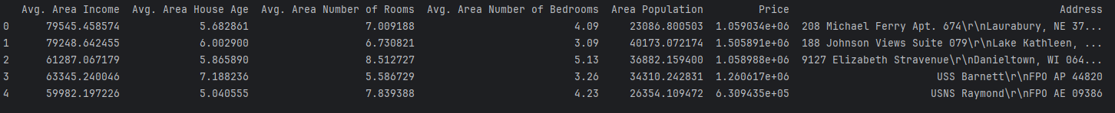

Explain what the columns of the data frame referenced above within this exercise represent.
These are all based in USA
Avg Area income: Avg income people make in a household in an area
Avg Area house Age: Avg age of a house based in each area
Avg Area number of rooms: Avg number of rooms for a house in an area
Avg Area number of bedrooms: Avg number of bedrooms for a house in an area
Area population: Number of people living in a given area
Price: the price of homes in an area
Address: The addresses of the homes

Exercise 9 (3 marks)
Replace the code that retrieves the data in Example 6 with the following code which imports and prepares the wine quality data set. Make any other adjustments as required.
PATH = "/Users/pm/Desktop/DayDocs/data/"
CSV_DATA = "winequality.csv"
dataset = pd.read_csv(PATH + CSV_DATA)
X = dataset[['fixed acidity', 'volatile acidity', 'citric acid', 'residual sugar',
'chlorides', 'free sulfur dioxide', 'total sulfur dioxide', 'density',
'pH', 'sulphates','alcohol']].values
y = dataset['quality']

Run the code after making the changes. Show the output here:
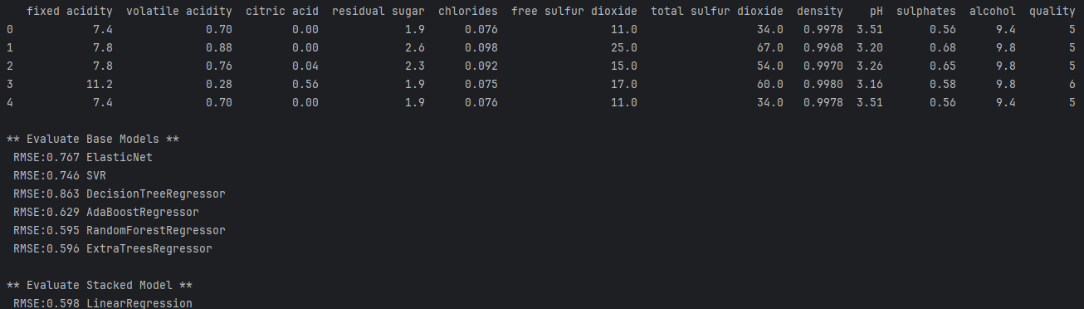

What model appears to perform the best and explain why you made that choice.
The best performing models here is the RandomForestRegressor as it has the lowest RMSE result in the base models

Stacking Classification

Example 7: Stacking for Classification
This example shows how to implement stacking for classification.
** Evaluate Base Models **
*** LogisticRegression
precision recall f1-score support
0 0.64 1.00 0.78 89
1 0.00 0.00 0.00 51

*** DecisionTreeClassifier
precision recall f1-score support
0 0.84 0.88 0.86 89
1 0.77 0.71 0.73 51

*** AdaBoostClassifier
precision recall f1-score support
0 0.80 0.89 0.84 89
1 0.76 0.61 0.67 51

*** RandomForestClassifier
precision recall f1-score support
0 0.84 0.88 0.86 89
1 0.77 0.71 0.73 51

** Evaluate Stacked Model **
*** LogisticRegression
precision recall f1-score support
0 0.83 0.88 0.85 89
1 0.76 0.69 0.72 51

Here is the code:
from sklearn.linear_model import LogisticRegression
from sklearn.tree import DecisionTreeClassifier
from sklearn.ensemble import AdaBoostClassifier
from sklearn.ensemble import RandomForestClassifier
from sklearn.metrics import classification_report
from sklearn.model_selection import train_test_split
import numpy as np
import pandas as pd

# Show all columns.
pd.set_option('display.max_columns', None)
pd.set_option('display.width', 1000)

# Prepare the data.
PATH = "/Users/pm/Desktop/DayDocs/data/"
CSV_DATA = "Social_Network_Ads.csv"

df = pd.read_csv(PATH + CSV_DATA)
df = pd.get_dummies(df,columns=['Gender'])
del df['User ID']

X = df.copy()
del X['Purchased']
y = df['Purchased']

def getUnfitModels():
models = list()
models.append(LogisticRegression())
models.append(DecisionTreeClassifier())
models.append(AdaBoostClassifier())
models.append(RandomForestClassifier(n_estimators=10))
return models

def evaluateModel(y_test, predictions, model):
print("\n*** " + model.__class__.__name__)
report = classification_report(y_test, predictions)
print(report)

def fitBaseModels(X_train, y_train, X_test, models):
dfPredictions = pd.DataFrame()

# Fit base model and store its predictions in dataframe.
for i in range(0, len(models)):
models[i].fit(X_train, y_train)
predictions = models[i].predict(X_test)
colName = str(i)
dfPredictions[colName] = predictions
return dfPredictions, models

def fitStackedModel(X, y):
model = LogisticRegression()
model.fit(X, y)
return model

# Split data into train, test and validation sets.
X_train, X_temp, y_train, y_temp = train_test_split(X, y, test_size=0.70)
X_test, X_val, y_test, y_val = train_test_split(X_temp, y_temp, test_size=0.50)

# Get base models.
unfitModels = getUnfitModels()

# Fit base and stacked models.
dfPredictions, models = fitBaseModels(X_train, y_train, X_val, unfitModels)
stackedModel = fitStackedModel(dfPredictions, y_val)

# Evaluate base models with validation data.
print("\n** Evaluate Base Models **")
dfValidationPredictions = pd.DataFrame()
for i in range(0, len(models)):
predictions = models[i].predict(X_test)
colName = str(i)
dfValidationPredictions[colName] = predictions
evaluateModel(y_test, predictions, models[i])

# Evaluate stacked model with validation data.
stackedPredictions = stackedModel.predict(dfValidationPredictions)
print("\n** Evaluate Stacked Model **")
evaluateModel(y_test, stackedPredictions, stackedModel)

Exercise 10 (3 marks)
Show a screenshot of the data frame that is used for input that is used to fit the stacked model in this exercise. Please make it reader-friendly by whatever means you feel is appropriate.
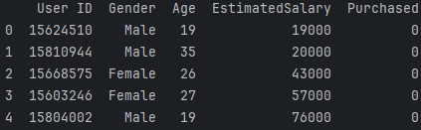

Explain what the columns of the data frame referenced above within this exercise represent.
UserID: The id of a user
Gender: Gender of the user
Age: Age of the user
Estimated Salary: Guess of a user’s salary
Purchased: Number of items purchased from the social network ad

Exercise 11 (3 marks)
Replace the code that retrieves the data in Example 6 with the following code which imports and prepares the iris data set. Make any other adjustments as required.
# Get the housing data
df = pd.read_csv('/Users/pm/Downloads/iris_v2.csv')

dict_map = {'Iris-setosa':0,'Iris-versicolor':1, 'Iris-virginica':2}
df['target'] = df['iris_type'].map(dict_map)

y = df['target']
X = df.copy()
del X['target']
del X['iris_type']

Run the code after making the changes. Show the output here:
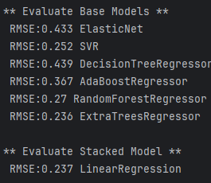

What model appears to perform the best and explain why you made that choice.
ExtraTreesRegressor as it has the lowest RMSE output. This indicates less error when predicting and is much closer to the original values.

